**GIT HANDSON**

Exercise – 2

**Gitignore File:**

Simple text file that tells Git which files or folders to intentionally ignore in a project.This prevents unnecessary or sensitive files from being included in your project's history.

**How to Ignore Unwanted Files Using .gitignore**

Ignoring files with .gitignore is a straightforward process that involves creating the file and adding patterns to it.

* **Create a .gitignore File:** In the root directory of your project, create a new file and name it .gitignore.
* **Add File or Folder Names:** Open the .gitignore file and add the names of the files or folders you want to ignore, with each entry on a new line. For example, to ignore a file named debug.log, you would simply add debug.log to the file. To ignore an entire directory called build/, you would add build/.
* **Use Patterns for Broader Matches:** You can use special characters called wildcards to ignore multiple files at once. For instance, to ignore all files that end with .log, you would add *.log to your .gitignore file.

**Step1**: Create Required file and folder for testing. Log folder and sample log file

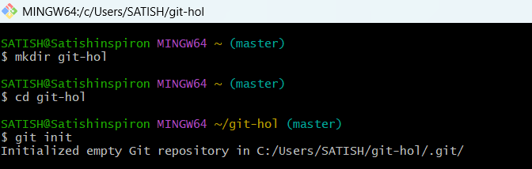

**Step2**: Check your repository's status to see that Git is tracking the new file and folder

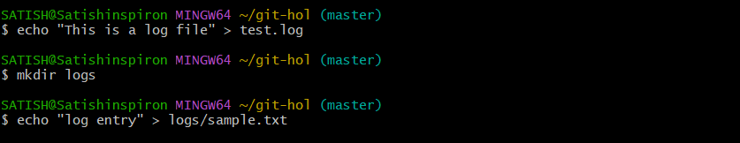

**Step3**: Create and Update the rule in .gitignore File



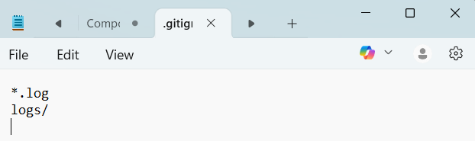

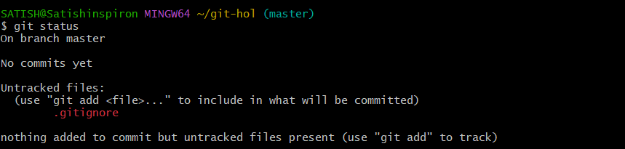

**Step4**: Add and commit the .gitignore file so that these rules are shared with anyone else who works on the project.

